ITRG Data Replication

Author: SAP B1 TECH TEAM - 10 Jan 2017

Version 1.0

# Introduction

The entities in this document refer to the company databases to be setup in SAP Business One. The setup will be done in the **Source Entity**.

Replication will be triggered from the ***Source entity*** to ***Target entity***.

ITRG requires the following master data to be replicated:

* Exchange rate (Singapore Entities)
* Chart of Accounts
* Item Code
* Supplier Master
* Supplier Price List
* BoM (Recipes)

# ITRG Replication – General Setup

Each entity (***Source Database***) will have a setup table to indicate the ***Target database*** to copy the master data from. When master data is being created or updated in the source database, the entity will be updated with the delta changes automatically with human intervention.

**Deletion will not be replicated.** This is because an item can be created in the source database and replicated to the target databases. This item may not be used in the source database, but may have been used in the target databases. Hence any automatic deletion replication may be fail in the target database. If the user recreates the deleted item with a different purpose, this may conflict with the item transaction that failed to be deleted in the target database.

***The Data Replication process flow as below:***

Source Entity

Transaction Notification

Item Master Data

Finance

Business Partner Master Data

Replication Setup

Integration database – Temp Table insert data

Replication Process - UI

Success

Sync Status will be updated as Failure

Sync Status will be updated as Success

Fresh/Failure transactions

NO

YES

YES

Target Entity

Replication completed in target database

**Process Flow Explanation:**

* The data replication process flow begins in master data replication setup in source database.
* If any Master data’s are created or updated in the source entity; these details will be captured in the integration database for replication.
* Replication process will fetch the transaction from temp table from integration database; it will be either fresh transaction or failure transactions.
* Replication process will trigger to the target entities based on the setup.
* If Replication process is successful then success flag will be updated in both Replication table and temp table against the each transaction.
* If Replication is unsuccessful due to some reason then failure flag will be updated in both Replication table and temp table against the each transaction.
* Success flag entries will not come to replication queue again.
* Later failure flag entries need to review and rectify, then again failure entries will go for replication.
* The Same process will repeat as mentioned above.
* The Same process will be followed by all the three master replications.

**1. Replication Setup:**

There are three types of master data replication setup’s we need to configure based on the target entity.

1. BP Master data replication setup.

2. Finance Master data replication setup.

3. Item Master data replication setup.

**1.1 BP Master Data Replication Setup:**

Find the below screen shot, how to setup the BP Master replication.

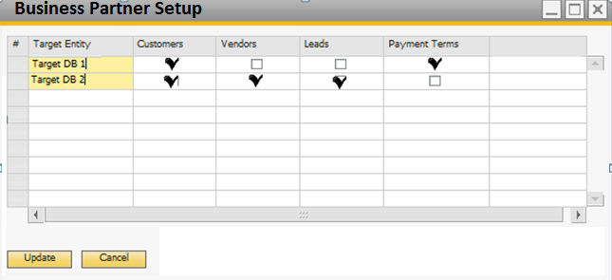

1. Select the ‘**Target Entity/Database**” in target entity column and define what are the replication process we need to do for that target entity. Target Entity is selection option and target entities will be filled from the target entity credential table.

2. See the Example of the above screen shot, in the target Entity/Database “**Target DB 1**” , we need to replicate the “payment terms” and “customers”.

3. In the target entity/Database “Target DB 2”, we need to replicate the “Customers”, “vendors” and “Leads” only.

4. Customers and Vendors will be managed by unique Business Partner (BP) groups.

5. **Assumptions & Error Handling:**

* + The customer and vendor code in the target entity should be the same as the source entity.
  + Users should not manually create in the target entities or when they manually create, they should choose a standard format that will not conflict with the BP codes to be replicated.
  + In the event that BP code already exists in the target entity and cannot be amended due to existing transactions, users will need to amend the BP code in the source entity.
  + Users should only start transacting using the new BP code when the intended replication is successful across all target entities.

**1.2 Finance Master Data Replication Setup:**

Find the following screen shot, how to setup the Finance Master Data replication.

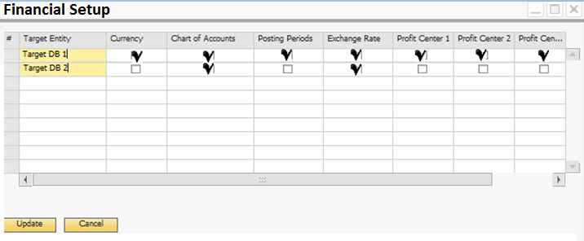

1. Select the ‘**Target Entity**” in the target entity column and define what are the replication we need to do for that target entity. Target Entity is selection option and target entities will be filled from the target entity credential table.

2. See the Example of the above screen shot, in the target Entity/Database “**Target DB 1**” , we need to replicate the “curreny”, “COA”, “Posting Periods”, “Exchange rates” and “all five profit center codes”.

3. In the target entity/Database “**Target DB 2**”, we need to replicate “COA” and “Exchange rates” only.

4. Currency Code and Chart of Accounts can be replicated or updated if already exists.

5. Posting Period can be replicated if the starting date of the next fiscal period in the target entity is the same as the source entity.

6. The exchange rates can be replicated from the source to the target entity if the following conditions apply:

1. The currency code (e.g. USD, GBP) exists in both source and target entities.
2. The local and system currency of the source entity is the same as the local and system currency of the target entity.
3. The exchange rate representation in local terms (indirect or direct) must be the same in both source and target entities.

7. If the dimension level (1 to 5) is activated in both the source and target entities, new profit center’s can be replicated. Changes in the profit centres such as effective dates will not be replicated.

**1.3 Item Master Data Replication Setup:**

Find the following screen shot, how to setup the Item Master Data replication.

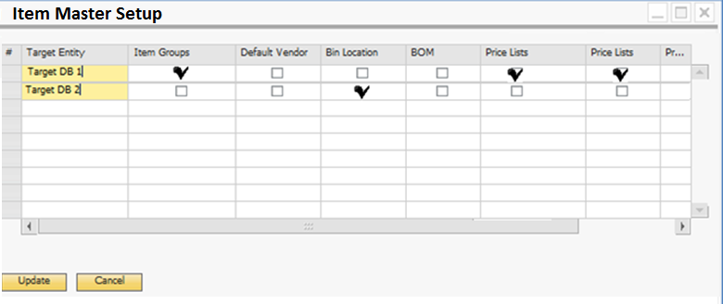

1. Select the ‘**Target Entity**” in the target entity column and define what are the replications we need to do for that target entity. Target Entity is selection option and target entities will be filled from the target entity credential table.

2. See the Example of the above screen shot, in the target Entity/Database “**Target DB 1**” , we need to replicate the “Item Groups” and “Price Lists”.

3. In the target entity/Database “**Target DB 2**”, we need to replicate the “BOM” only.

4. Item master data will be managed by unique Item groups.

5. By default, item groups will not be replicated unless the “Replicate Item Group” is ticked.  
** Item Group Name will be the key instead of Item Group Code.  
Hence users must not overwrite and amend the item group name without understanding the impact of the changes.

6. Warehouse (outlet) will not be replicated because warehouse (outlet) code must be unique across the ITRG landscape.

7. Some common stock locations (bin location) within each warehouse (outlet) can be replicated, for example “TRANSFER”, “NON-FOOD” and “STORE”. By default, the bin locations will not be replicated to every warehouse unless the “Replicate Bin Locations” is ticked. Bin locations in the inclusion list will be replicated.  
  
8. By default, Price Lists (Outlet Manager Customized Price Lists by Business Partner by UoM) will not be replicated unless the “Replicate by Business Partner by UoM” is ticked.

**1.4 Integration Database – Temporary Table:**

Whenever the master data’s are adding or updating in the source databases/entities, the data will be inserted/updated into the integration database for replication.

Find the below screen shot, how the data will be stored in the integration database when adding or updating in source databases.

|  |  |  |  |  |  |  |  |
| --- | --- | --- | --- | --- | --- | --- | --- |
| Master Type | Unique ID | Trans Type | Code | Name | Sync Status | Sync  Date | Error Message |
| BP Master | 1000 | Customer | C00001 | ABC and CO | NO |  |  |
| BP Master | 1001 | Vendor | V00001 | XYZ and CO | NO |  |  |
| BP Master | 1002 | Lead | L00001 | TATA | NO |  |  |
| BP Master | 1003 | Customer | C00001 | ABC and CO | NO |  |  |
| BP Master | 1004 | Payment | CASH | CASH | NO |  |  |
| BP Master | 1005 | Payment | 30 Days from Invoice | 30 Days from Invoice | NO |  |  |
| BP Master | 1006 | BP Group | Domestic Customers | Domestic Customers | NO |  |  |
| Finance | 1007 | COA | 12000021 | Expense Account | NO |  |  |
| Finance | 1008 | COA | 12000022 | Revenue Account | NO |  |  |
| Finance | 1009 | Currency | INR | Indian Currency | NO |  |  |
| Finance | 1010 | Cost Centre | Profit1 | Profit1 | NO |  |  |
| Finance | 1011 | Cost Centre | Profit2 | Profit2 | NO |  |  |
| Item Master | 1012 | Items | Item0001 | Item Code 1 |  |  |  |
| Item Master | 1013 | Items | Item0002 | Item Code 2 |  |  |  |
| Item Master | 1014 | BOM | Item0001 | Item Code 1 |  |  |  |
| Item Master | 1015 | Item Group | Consumables | Consumables |  |  |  |
| Item Master | 1016 | Item Group | Finished Goods | Finished Goods |  |  |  |
| Item Master | 1017 | Price List | Price List New | Price List New |  |  |  |

**Integration Table Properties:**

* “Master type” column will indicate that what type of master data transaction is stored.
* “Unique ID” is the auto incrementing code, which is help us to filter the data while replication. It will be unique values.
* “Tran’s type” will indicate that what type of transaction is added or updated.
* “Code and Name” will store the basic information of the transaction.
* “Sync Status” will indicate about the status of replication, whether replication is success or failure. These details will be updated once the replication process is completed.
* “Sync Date” is the date and time of the replication process, it will update automatically.
* “Sync Message” column will be updated the reason failure, if replication gets any error.

**2. Replication Process:**

Replication process will trigger from the source entity by Master data replication screen, find the below screen shot. Find the below replication for business partner master data.



Find the below, replication process for Financial master data.



**2.2 Master Data Replication screen Properties:**

* In header, we have to select the “master data type”.
* After selected “master data type”, the data will be fetched from the integration table and it will upload in the table.
* See the above screen, data being filled based on the selection.
* Just select the transaction that whichever transaction you want to replicate.
* Once replication process is completed then the success/unsuccessful flag and date will be updated in the sync status and sync date accordingly, also the same sync status flag and date will be updated in the temp table in integration Database.
* During the replication process if any transaction is not successful for all the target entities (2 entity success and 1 entity failure) then the same transaction will be considered as failure.
* Once replication is successful for target entities, the same transaction will not trigger again for the replication queue.
* Based on the sync status the transaction will be filtered.
* For Financial master data filtration, there are two check will be enabled for replication such as “Posting periods” and “Exchange Rates”.
* These two check boxes will be invisible for remaining two master data replications.
* Replication process transaction details will not be saved anywhere instead the replication status will be updated in the integration table.

**2.3 Find the below screen shot, after the replication process.**



* After completed the replication process, the status will be updated to the sync status column.
* See the above screen shot; there are two transaction replications are unsuccessful due to some reason. This is update as failure flag in sync status column.
* The date of replication will be updated in the sync date column.
* Once sync status became success then the same entry will not replicate again for the same target entity.
* The same process will be followed to other two types of master data replications.

Find the below screen shot, to explain how temp table will update after the replication process.

|  |  |  |  |  |  |  |  |
| --- | --- | --- | --- | --- | --- | --- | --- |
| Master Type | Unique ID | Trans Type | Code | Name | Sync Status | Sync  Date | Error Message |
| BP Master | 1000 | Customer | C00001 | ABC and CO | YES | 2017-01-10 17:16:05.970 |  |
| BP Master | 1001 | Vendor | V00001 | XYZ and CO | YES | 2017-01-10 17:16:05.970 |  |
| BP Master | 1002 | Lead | L00001 | TATA | YES | 2017-01-10 17:16:05.970 |  |
| BP Master | 1003 | Customer | C00001 | ABC and CO | YES | 2017-01-10 17:16:05.970 |  |
| BP Master | 1004 | Payment | CASH | CASH | NO | 2017-01-10 17:16:05.970 | No Access |
| BP Master | 1005 | Payment | 30 Days from Invoice | 30 Days from Invoice | NO | 2017-01-10 17:16:05.970 | No Access |
| BP Master | 1006 | BP Group | Domestic Customers | Domestic Customers | YES | 2017-01-10 17:16:05.970 |  |

**3. Target Entity Credentials Setting:**

We need to capture the Target entity credentials for connecting the entity/database while posting from source entity to target entity.

This configuration details will be captured in the **Source Database**.

The following screen, indicating that what are the informations we need capture against the target entities.

|  |  |  |
| --- | --- | --- |
| Entity Name | Username | Password |
| Branch_DB1 | Manager | 1234 |
| Branch_DB2 | Manager | 5674 |
|  |  |  |
|  |  |  |

Thank you